Project Report: AI-Powered Smart Waste Classification System
1. Project Overview
The objective of this project is to automate the segregation of waste at the source. Traditional waste management relies on human intervention, which is error-prone and inefficient. This system utilizes a Hybrid Artificial Intelligence approach—combining a custom-trained neural network with a pre-trained object detection model (YOLO)—to classify waste as Biodegradable or Non-Biodegradable in real-time. The system is designed to be robust against environmental factors (like wind) and integrates with hardware (Arduino/Servos) to physically separate the waste.
2. Phase 1: Model Training (The "Specialist")
To recognize specific waste items relevant to the deployment environment, we utilized Google Teachable Machine.
2.1 Dataset Creation
We created a custom dataset with three distinct classes to handle all possible states of the bin:
Class 0: Blank – Represents the empty bin state. This prevents the model from hallucinating waste when the camera sees only the background.
Class 1: Bio – Contains images of biodegradable waste (e.g., food wrappers, paper, organic material).
Class 2: Non-Bio – Contains images of non-biodegradable waste (e.g., plastic cups, synthetic materials).
Data Statistics:
Bio Samples: 112 images
Non-Bio Samples: 110 images
Background: Controlled grey background to minimize noise
3. Phase 2: The Algorithm (Under the Hood)
The core technology powering the Teachable Machine model is Transfer Learning based on Convolutional Neural Networks (CNNs).
3.1 Architecture: MobileNet
We used MobileNet, a pre-trained efficient CNN architecture developed by Google.
Feature Extraction: MobileNet has already 'seen' millions of images (ImageNet dataset) and knows how to detect edges, shapes, textures, and patterns.
Transfer Learning: We stripped off the final classification layer of MobileNet and replaced it with our custom 3-class layer (Blank, Bio, Non-Bio). Only this final layer was fine-tuned to recognize our specific waste items.
4. Phase 3: The Hybrid Intelligence Architecture
A single model often fails in real-world scenarios (e.g., confusing a hand for bio-waste). To solve this, we architected a Hybrid Decision System.
4.1 The Two-Stage Pipeline
Stage 1: YOLOv8 (The Generalist)
Role: Ultralytics YOLOv8 Nano model trained on COCO.
Logic: Scans for common objects (Apples, Bottles). If detected with high confidence, it maps them immediately to Bio/Non-Bio using a Knowledge Map.
Stage 2: Custom Keras Model (The Specialist)
Role: Falls back to Teachable Machine if YOLO sees nothing.
Logic: Checks for specific wrappers trained manually. Operates with a strict confidence threshold (>0.60).
5. Phase 4: Environmental Robustness (Wind-Proofing)
A major challenge is sensor noise—wind shaking a wrapper or lighting flickers. We implemented a Temporal Voting System.
5.1 The Logic: "Stability over Speed"
Instead of reacting to every single video frame, the system uses a Rolling Buffer:
- Buffer: We store the last 15 frames (approx. 0.5s) in a memory queue.
- Voting: A Counter algorithm analyzes the buffer.
- Threshold: A decision is only finalized if 10 out of 15 frames agree.
6. Phase 5: Hardware Integration
The decision logic is translated into physical action via Serial Communication.
Interface: Python pySerial connects to Arduino over USB.
Protocol:
Signal '1' $→$ Arduino opens Green Bin (Bio)
Signal '2' $→$ Arduino opens Red Bin (Non-Bio)
Signal '0' $→$ Idle state
7. Phase 6: Code Walkthrough
- Block 1 (Init): Loads models (Keras/YOLO) and connects Serial.
- Block 2 (Main Loop): Captures frames. Checks YOLO first. If no detection, checks Keras model.
- Block 3 (Voting): Pushes result to buffer. Counts votes. If winner > 10 votes, confirms decision.
- Block 4 (Action): Sends '1' or '2' to Arduino if the decision changes.

8. Flow diagram
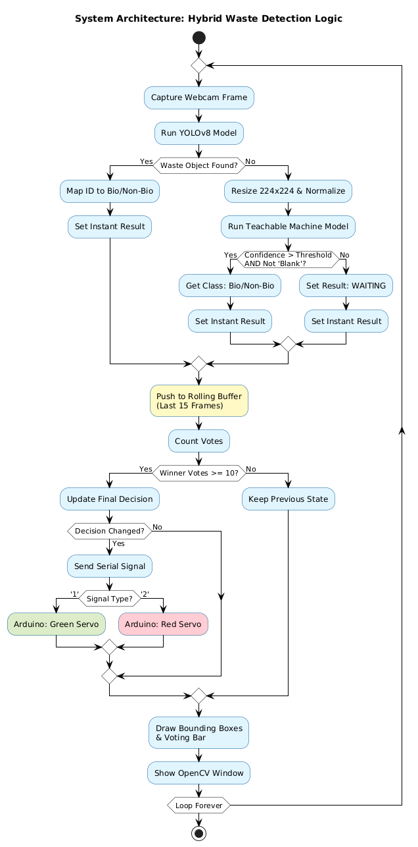
8. Sequence diagram

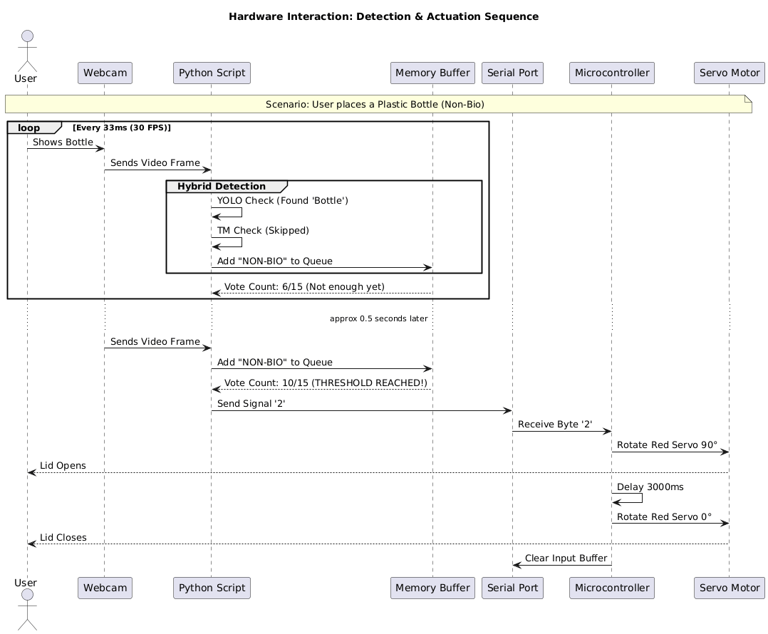

The 5-Step Logic Flow
The program runs in an infinite loop (30 times per second). Here is what happens in every single cycle:
1. Input: The "Eyes"
- The system turns on the webcam.
- It captures a single Video Frame (an image).
2. Analysis A: The "Generalist" (YOLOv8)
- The system first asks the YOLO model: "Do you see any standard objects like a Bottle, Apple, or Cup?"
- IF YES: It immediately marks the waste type (e.g., Bottle $\rightarrow$ Non-Biodegradable) and skips Step 3.
- IF NO: It proceeds to Step 3.
3. Analysis B: The "Specialist" (Teachable Machine)
- The system resizes the image to $224 \times 224$ pixels (Zoomed in).
- It asks your Custom Model: "Do you recognize this specific wrapper?"
- IF YES (and confidence > 90%): It marks the waste type (e.g., Wrapper $\rightarrow$ Biodegradable).
- IF NO: It marks the result as "WAITING".
4. The Filter: The "Voting System"
- The system takes the result from this specific millisecond and adds it to a History Buffer (a list of the last 15 frames).
- It counts the votes.
- Condition: If 10 out of 15 frames agree on the same result (e.g., "Bio"), the decision is confirmed.
- This filters out wind, camera glitches, and shaking hands.
5. Output: The "Hand" (Arduino)
- If the confirmed decision changes (e.g., from "Waiting" to "Bio"), the Python script sends a signal to the Arduino via USB:
  - Sends '1' $\rightarrow$ Open Green Bin.
  - Sends '2' $\rightarrow$ Open Red Bin.
- Finally, it draws a box around the object on the screen and shows the video to the user.

8. Conclusion
This project demonstrates a robust, end-to-end solution for automated waste segregation. By combining the generalized power of YOLO with the specialized training of Teachable Machine, and smoothing the results with a temporal voting algorithm, we have created a system that is accurate, stable, and ready for physical deployment.

